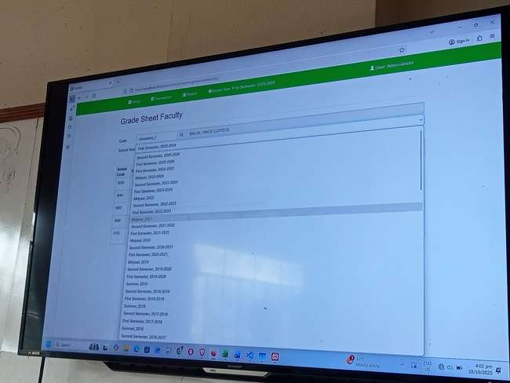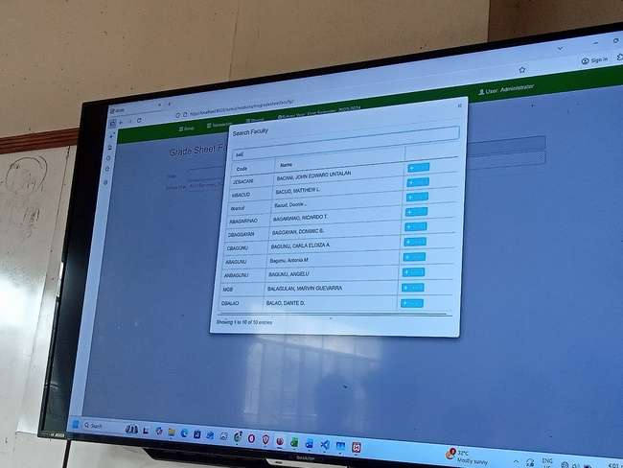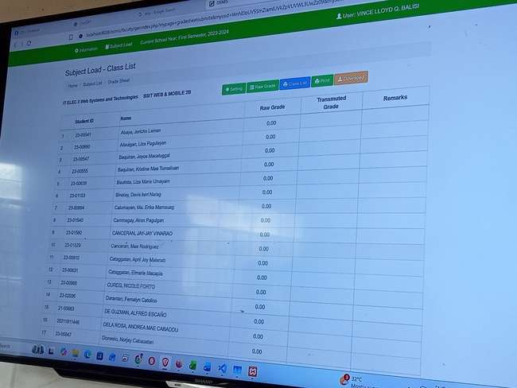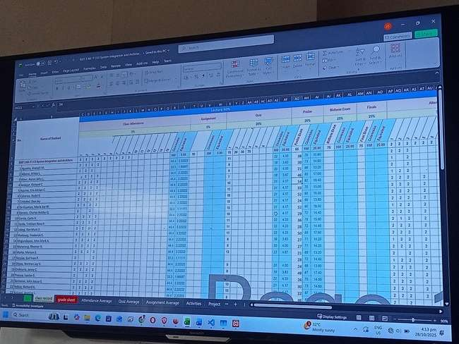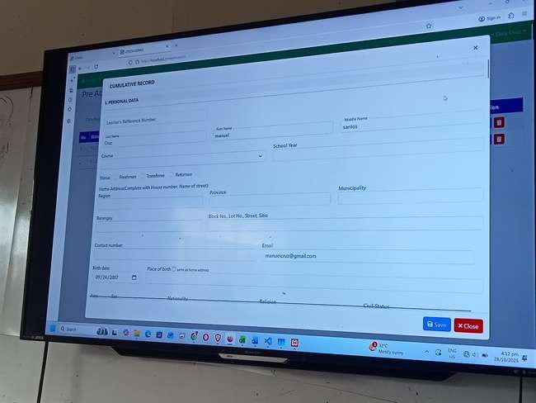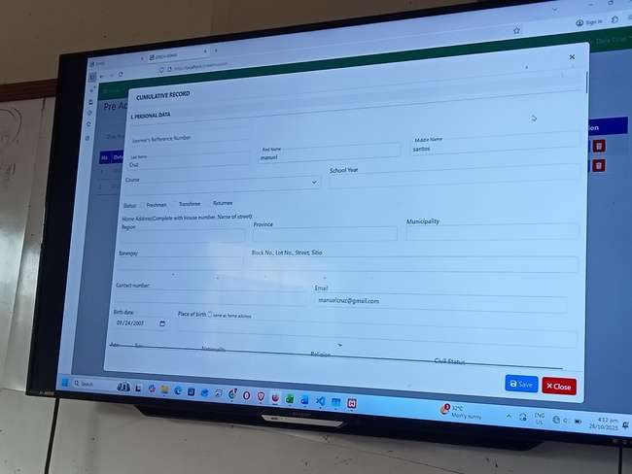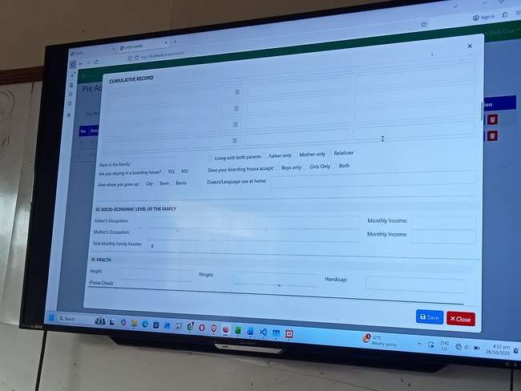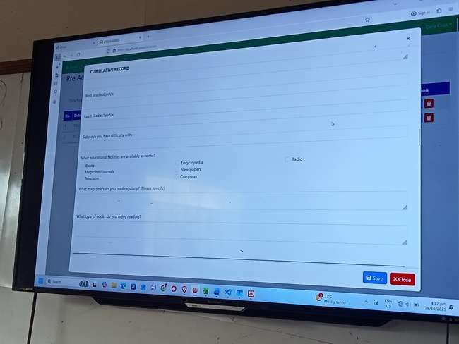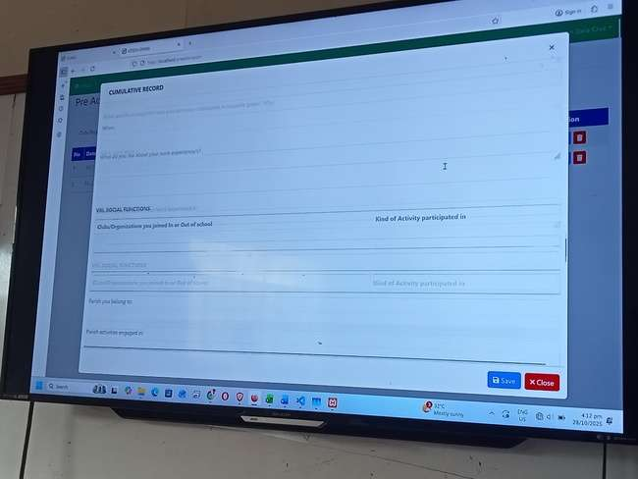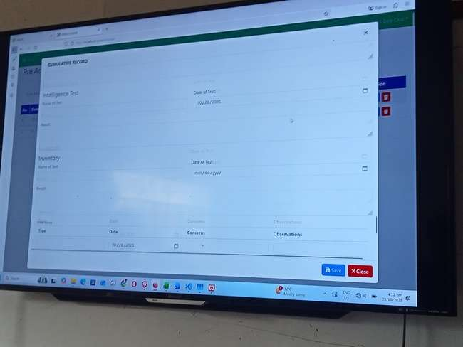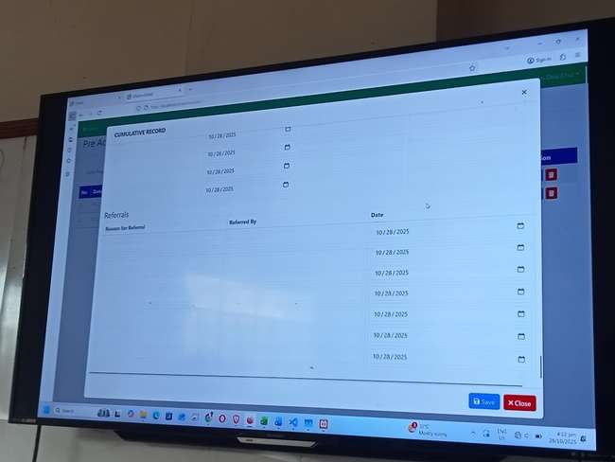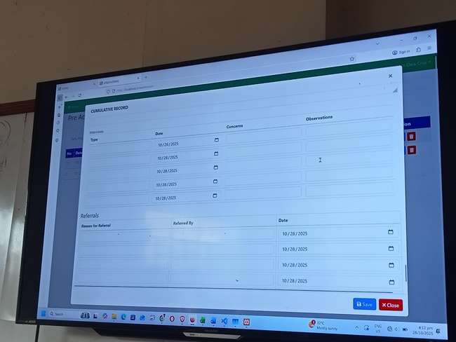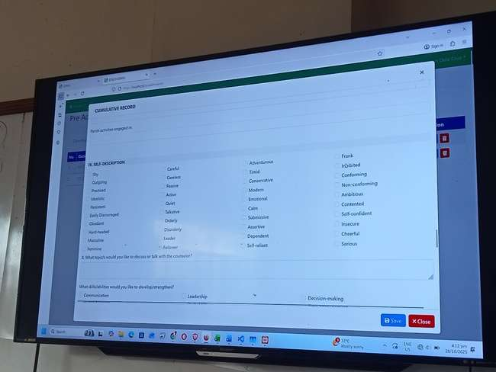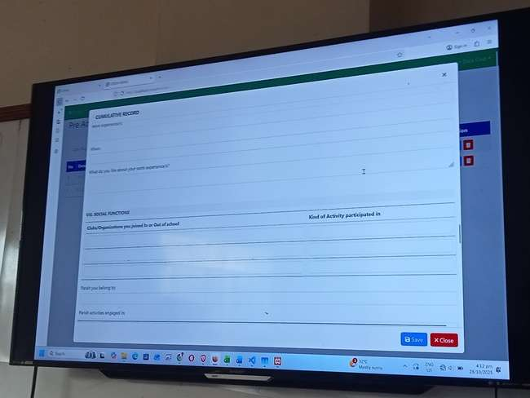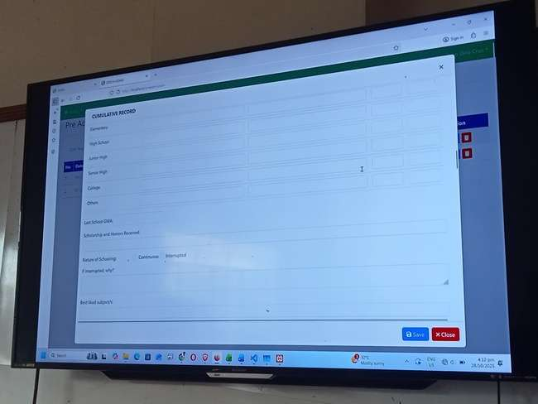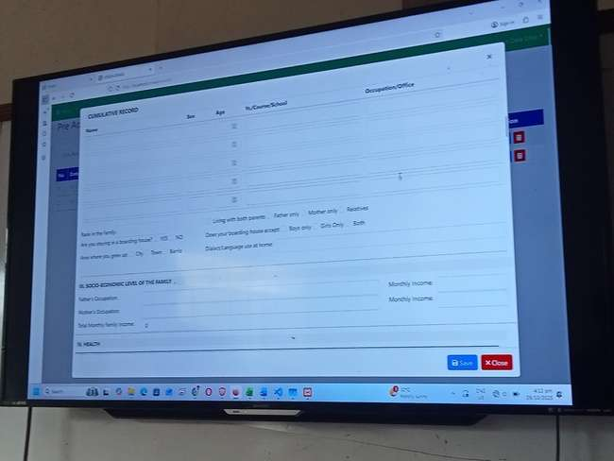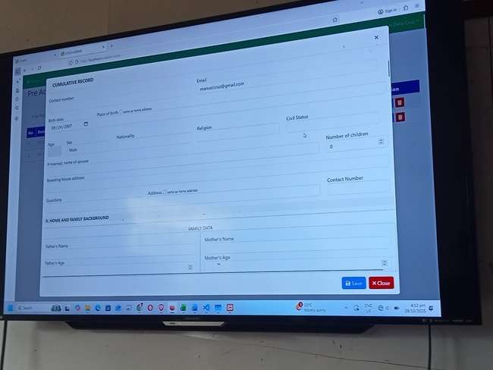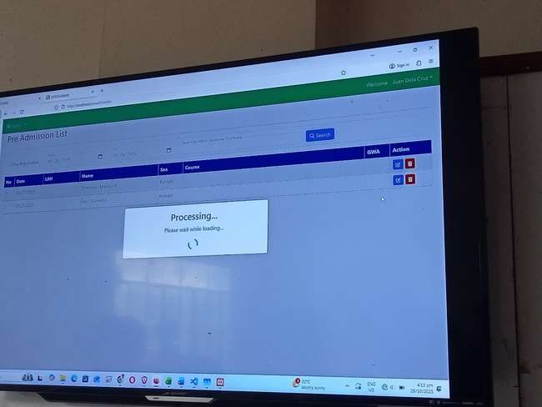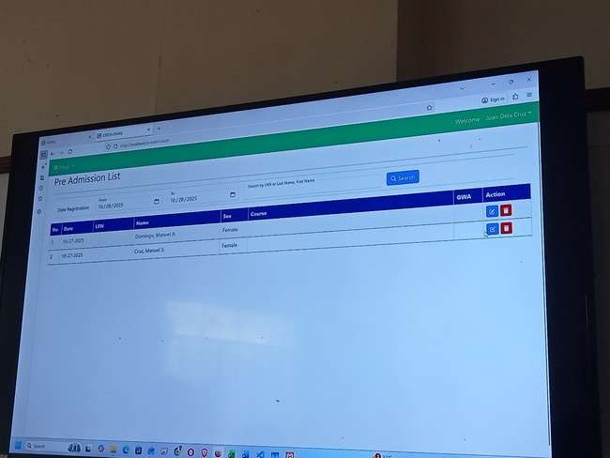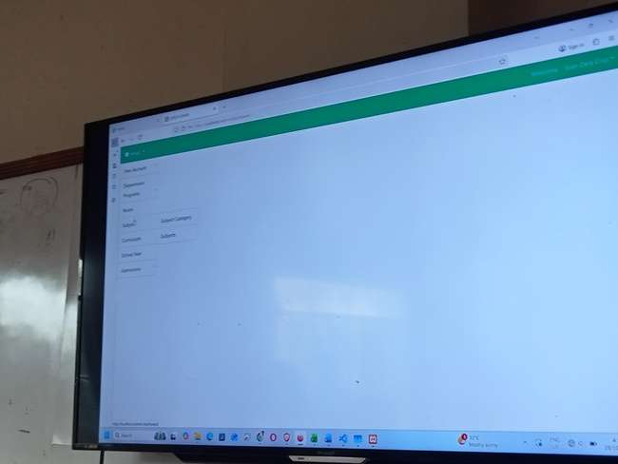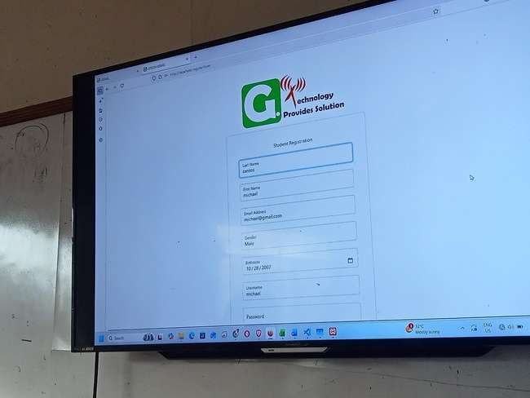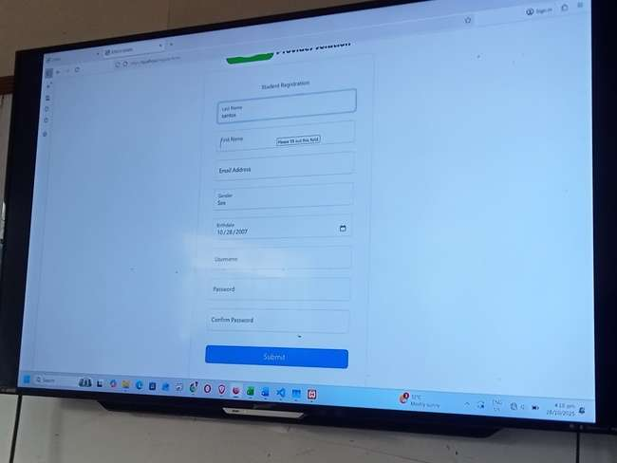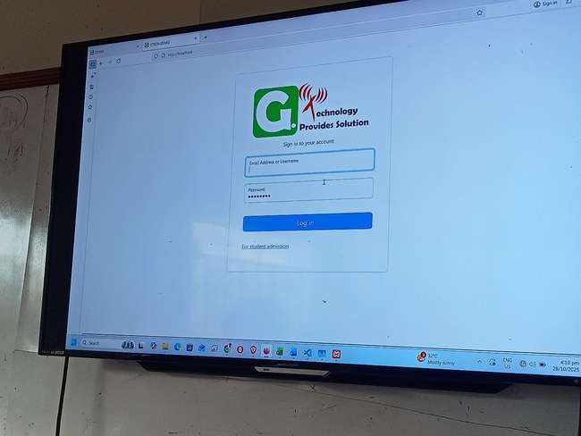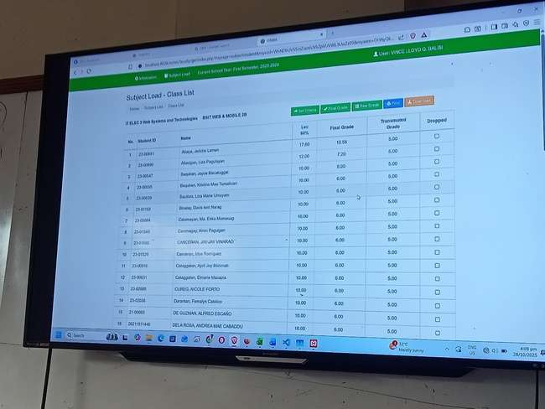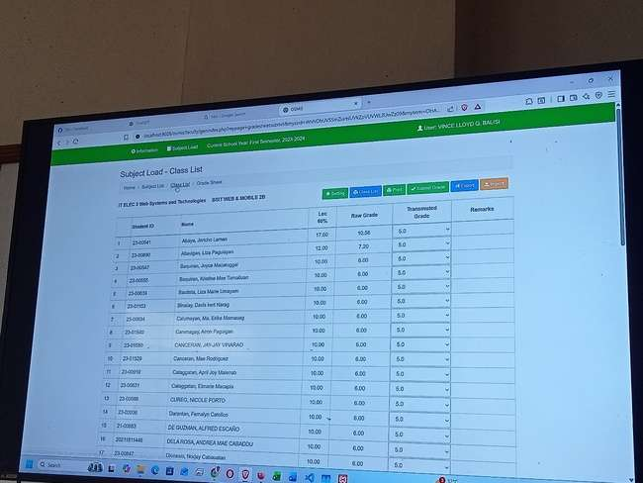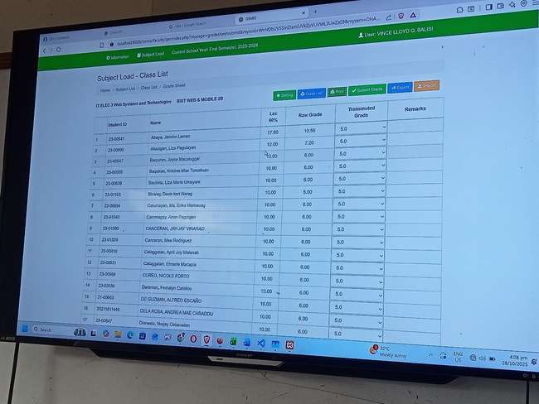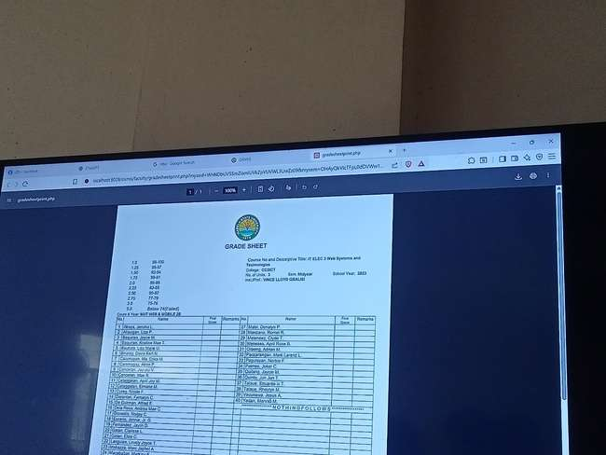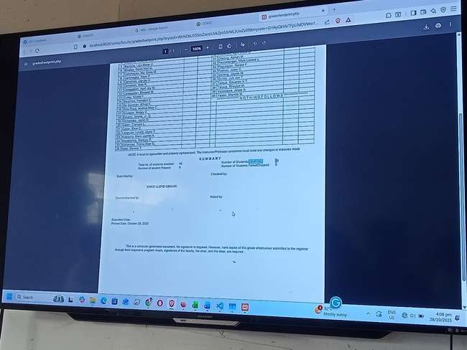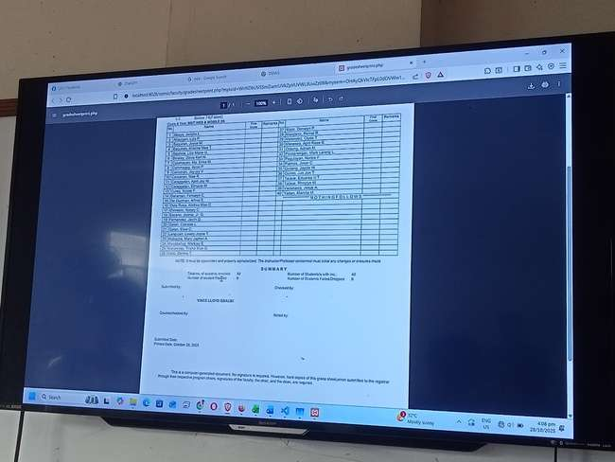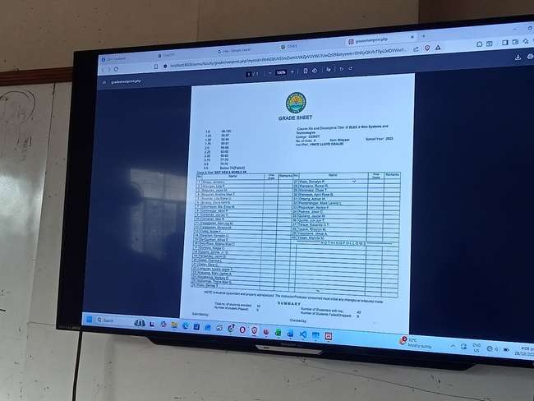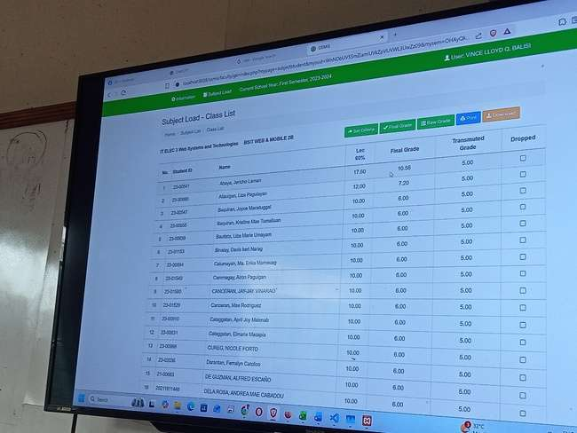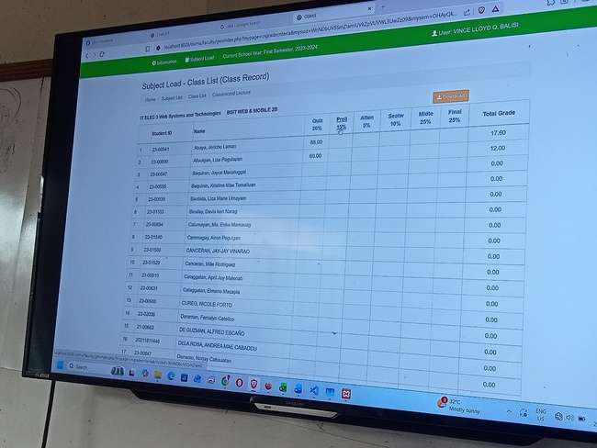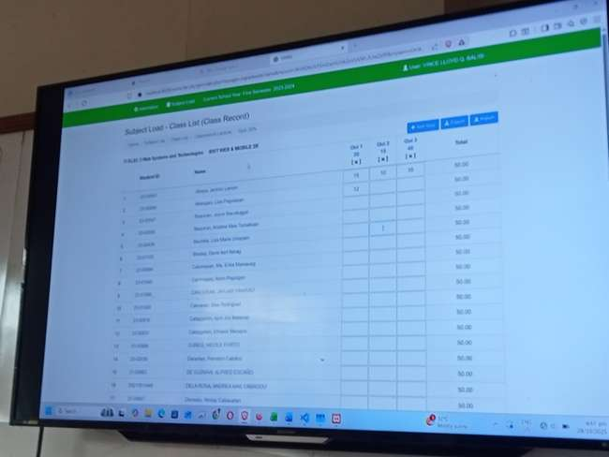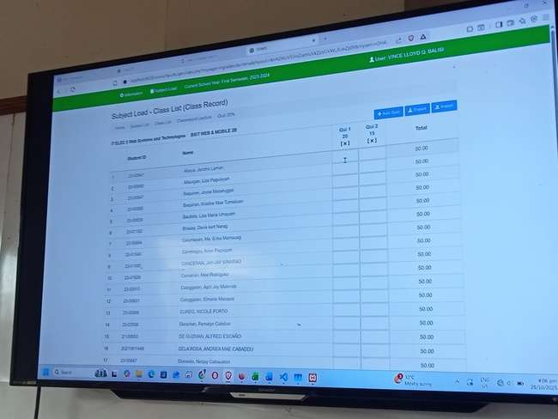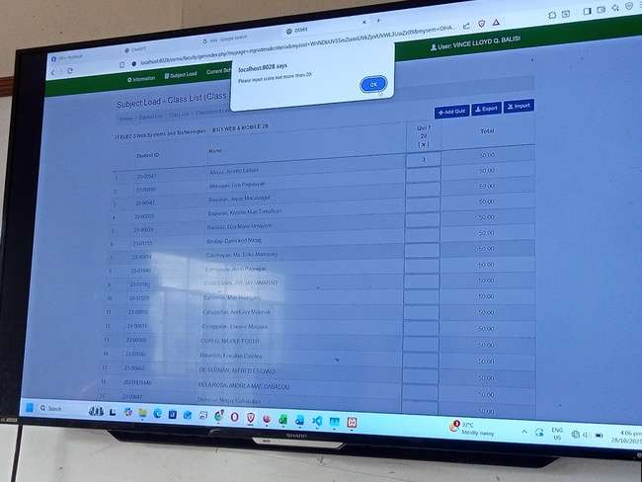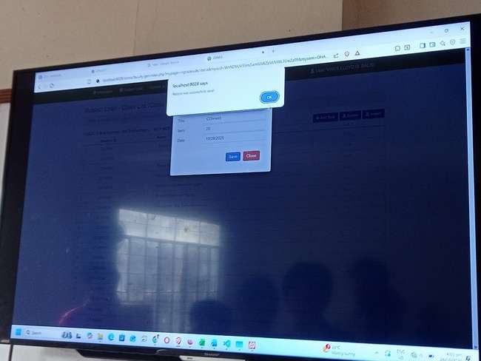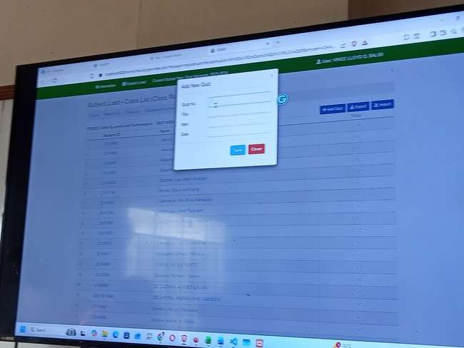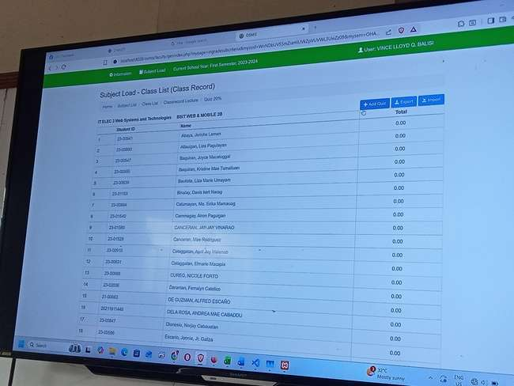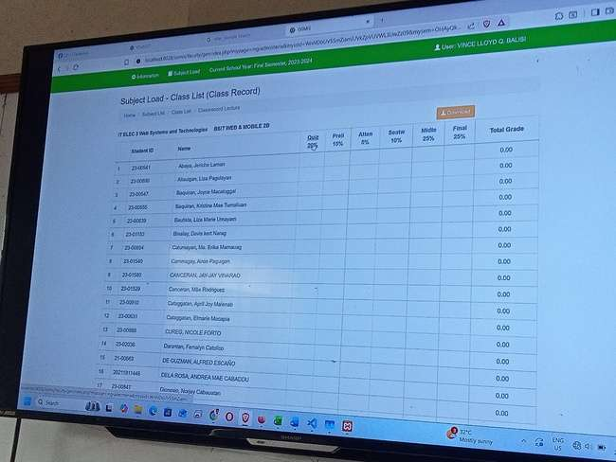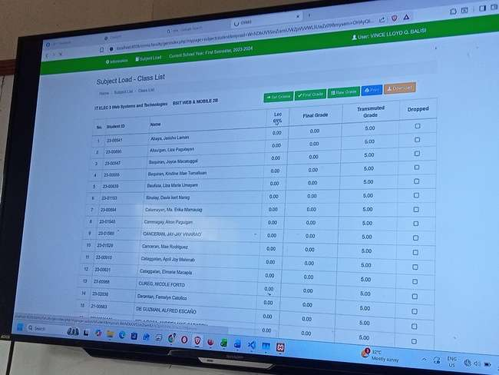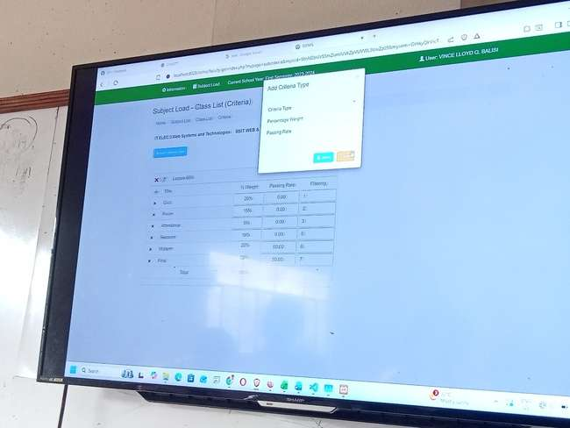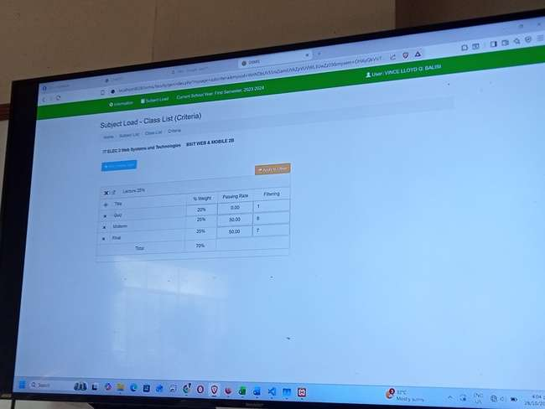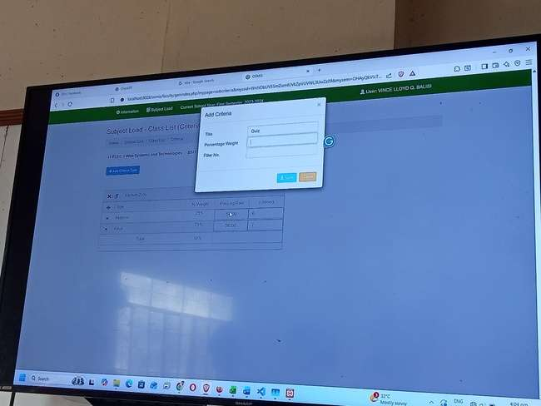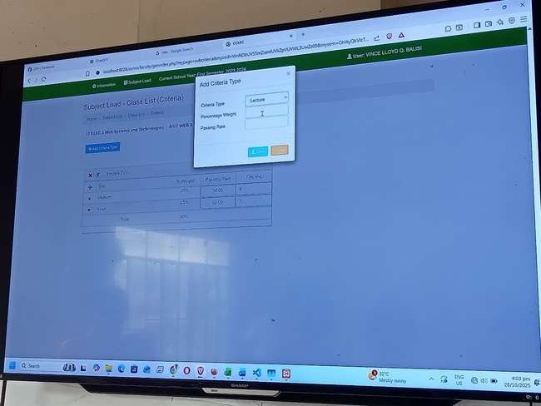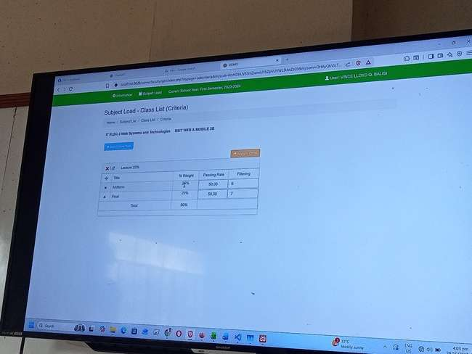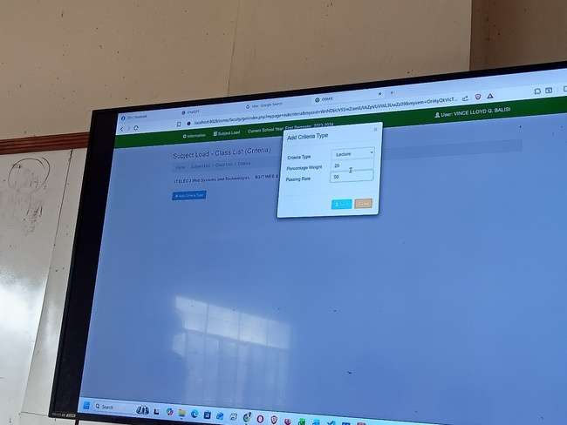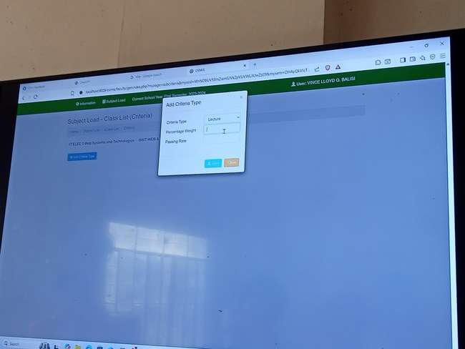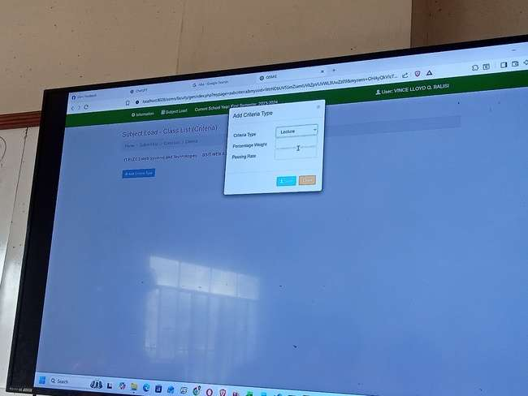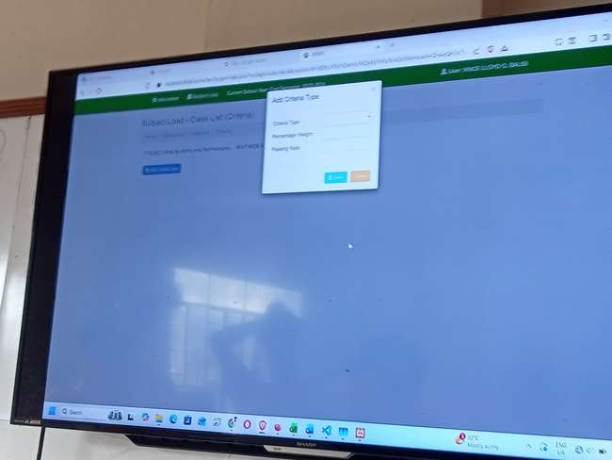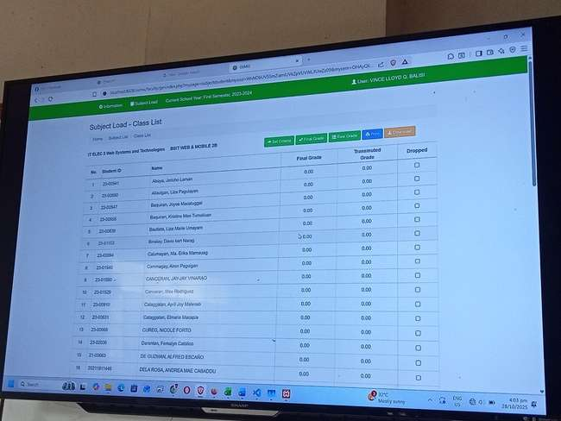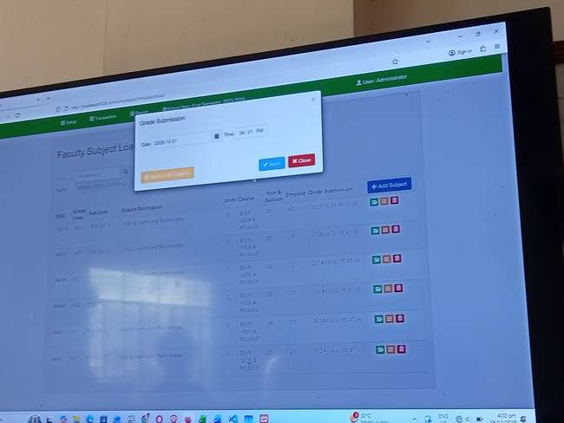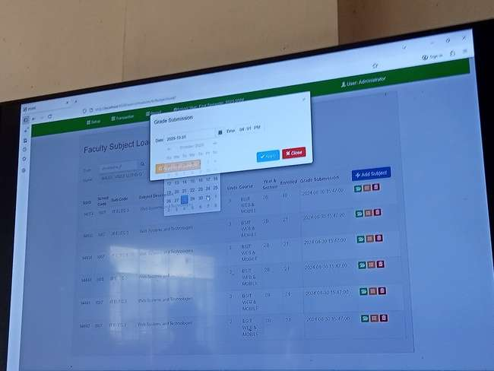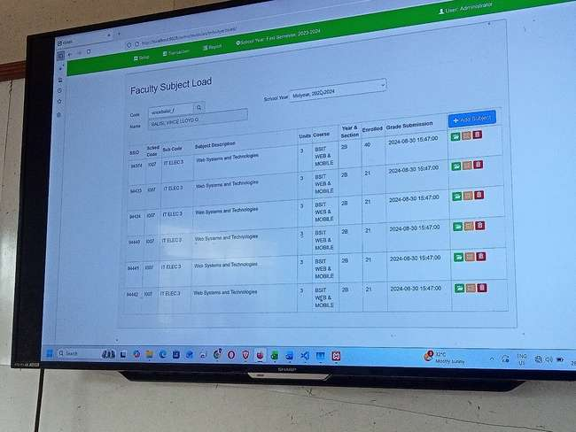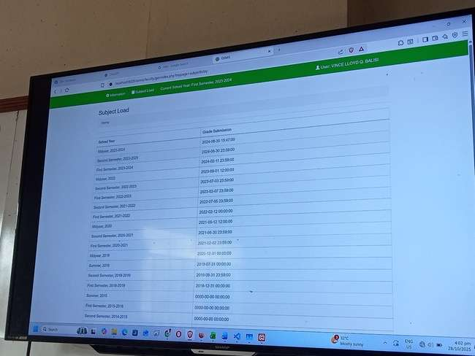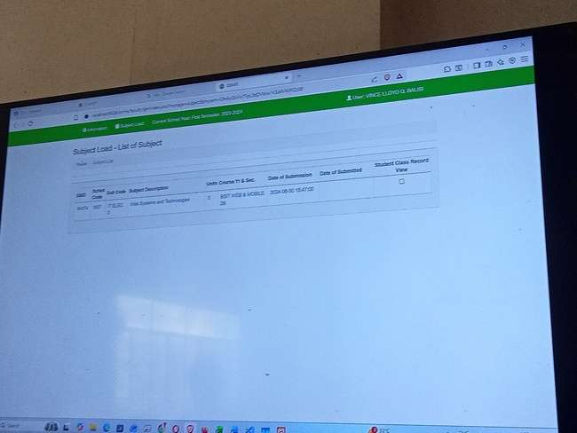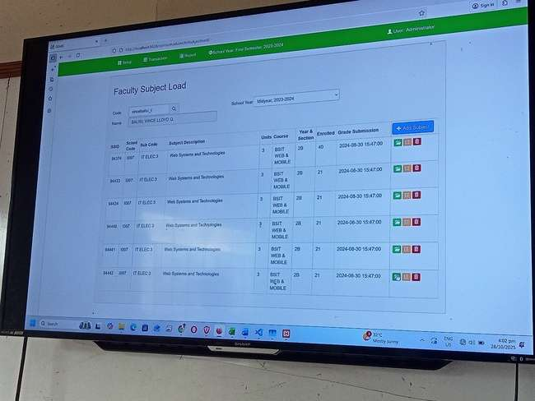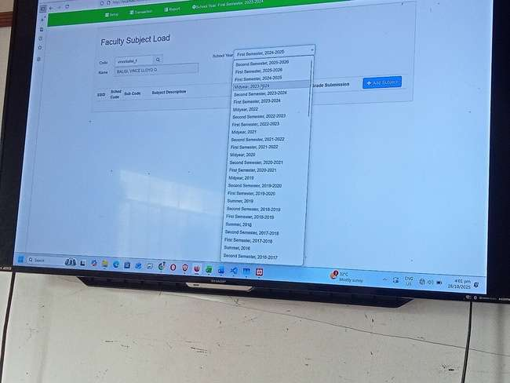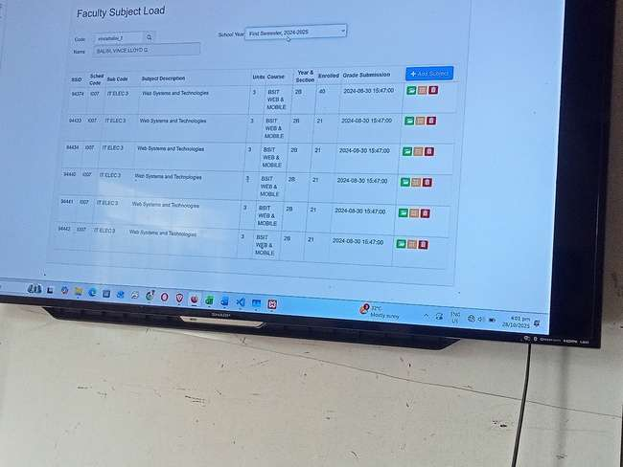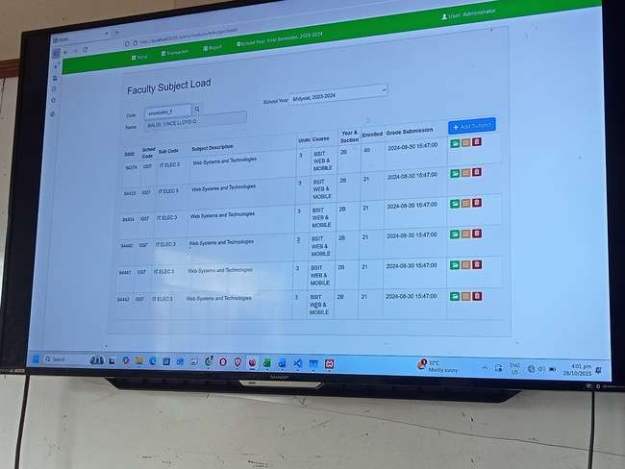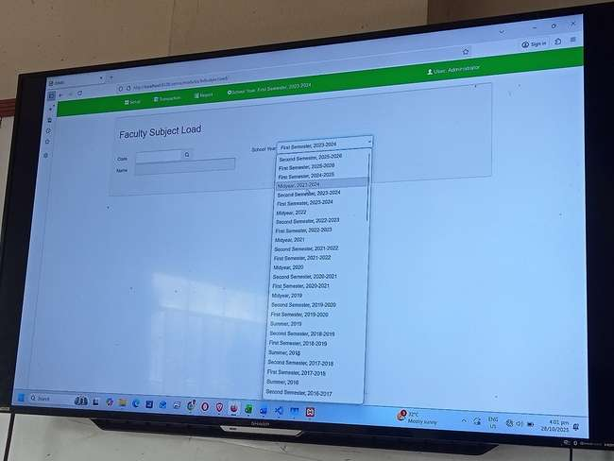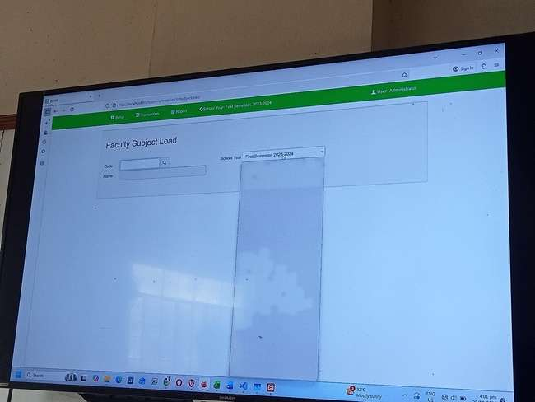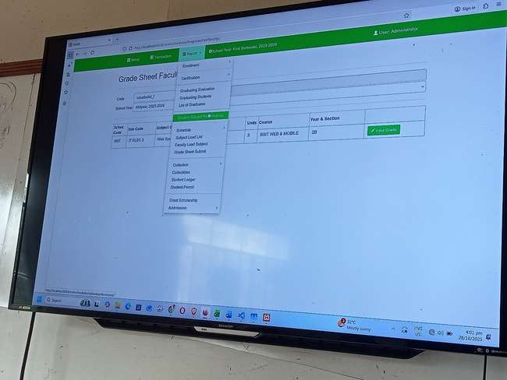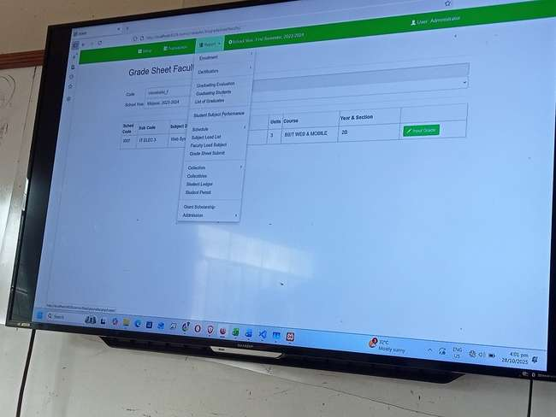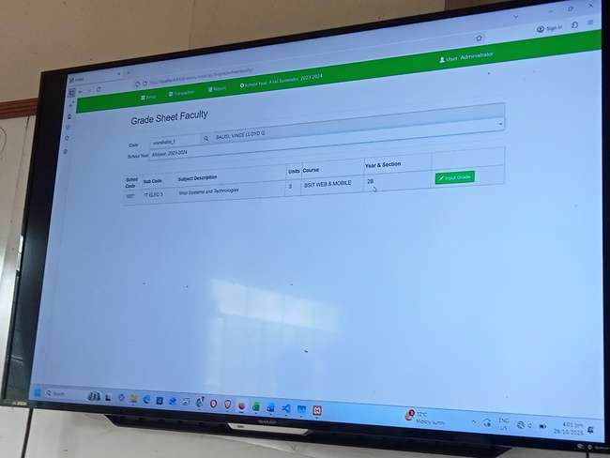

**What Went Well (The Good)**

* **Comprehensive Data Model:** The *idea* behind the "Cumulative Record" (Pages 5-10) is excellent. It aims to build a holistic profile of a student, including:
  + Personal Data
  + Socio-Economic Level of the Family
  + Health Information
  + Educational/Activity Functions
  + Psychological Test Data
* **Role-Based Access:** The system shows a distinction between a regular "User A" (Page 1) and a "User Administrator" (Page 2), which is a good security practice.
* **Search Functionality:** A "Search Faculty" feature (Page 2) is present, which is a necessary function for a system of this type.
* **Transparent Grading Structure:** The detailed grade sheet (Page 4) attempts to break down a student's final grade into multiple components (Attendance, Assignments, Activities, Project, Exam), which is a good practice for transparency.
* **Standardized Grade Process:** The main grade sheet (Page 3) has distinct columns for "Raw Grade," "Transmuted Grade," and "Remarks." This indicates a clear, standardized workflow for processing grades.
* **Contextual Information:** The "Subject Load-Class List" (Page 3) clearly displays the faculty member's name, the subject, and the class section, providing good context for the user.

**What Went Wrong (The Bad / Issues)**

* **CRITICAL FUNCTIONAL FAILURE:** The single most significant issue is that the system appears to be **broken**. On the "Subject Load-Class List" (Page 3), every single student listed has a "Raw Grade" and "Transmuted Grade" of **0.00** [cite: 586, 589, 595, etc.]. This indicates the core function of the page—calculating and displaying grades—is failing.
* **Severe UI/UX Flaws:** The user interface for the detailed grade sheet (Page 4) is unusable:
  + **Cryptic Headers:** Most columns are labeled with meaningless letters (AA, AB, AC, AD, etc.). A user has no way of knowing what data to enter here.
  + **Fragmented/Illegible Headers:** The main header is a jumbled, fragmented-looking line of text: "Attenstance Average Duc Average Astigatient Average Activities vities Project". This looks like multiple column headers were crammed into one unreadable space.
  + **Extreme Horizontal Scrolling:** The sheet on Page 4 is excessively wide, which would make data entry and review a very difficult task.
* **Critical Data Integrity Failures:**
  + **Duplicate Forms:** There are two separate screenshots for "PERCIONAL DATA" (Pages 5 and 6). A user should never have two different forms for the same set of data.
  + **Conflicting Data:** Because of the duplicate forms, there is conflicting information. The email for "manuel santos" is mamurouz@gmail.com on Page 5 but smanuelcru@gmail.com on Page 6. This is a critical failure in database design and data management.
* **Numerous Typographical Errors:** The system is full of spelling and typographical errors, which makes it look unprofessional and confusing.
  + Page 2: "Search **Farully**" (should be "Faculty").
  + Page 2: "**Gratte** Sheet **Pa**" (should be "Grade Sheet Page"?).
  + Page 2: "**Thowing** 10 of 10 **mins**" (should be "Showing 10 of 10 results"?).
  + Page 3: "**me Goor**" (Unclear, likely a broken data field).
  + Page 3: "Scott **Semesan**" (should be "Second Semester"?).
  + Page 4: "**Attenstance**" (should be "Attendance").
  + Page 4: "**Astigatient**" (likely a typo for "Assignment").
  + Page 5 & 6: "**PERCIONAL** DATA" (should be "PERSONAL").
  + Page 9: "**VILJANDAL** FUNCTIONS" (Unintelligible, possibly "EDUCATIONAL" or "EXTRA-CURRICULAR").
* **Poor/Corrupted Data Display:**
  + On the faculty list (Page 2), names like "**Haut Doome**" and "**BRAGARNAO**" appear, which look like test data or corrupted entries.
* **Dated and Poor Visual Design:** The overall aesthetic (fonts, spacing, button styles, layout) is very dated, cramped, and visually unappealing, which contributes to the poor user experience.

**What to Improve (Recommendations)**

* **1. Fix Core Grade Calculation (Highest Priority):** The first and most important step is to debug and fix the grade calculation logic. The "Raw Grade" and "Transmuted Grade" columns (Page 3) must correctly calculate and display the totals based on the component scores entered on Page 4.
* **2. Complete Overhaul of Grade Sheet UI/UX:**
  + **Replace Cryptic Headers:** All headers like AA, AB, AC must be replaced with clear, descriptive labels (e.g., "Quiz 1," "Assignment 2," "Seatwork 1").
  + **Fix Header Table Structure:** The jumbled header ("Attenstance...") must be properly formatted into a standard HTML table header (<thead>) with distinct, readable columns for "Attendance," "Assignment Avg.," "Activity Avg.," "Project," "Midterm Exam," and "Final Exam."
  + **Redesign Layout:** Redesign the page to avoid extreme horizontal scrolling. Consider using a modal (pop-up) window to edit the grades for a single student, or use a tabbed interface.
* **3. Fix All Typographical Errors:** Conduct a complete audit of all text in the application and correct the many spelling mistakes (e.g., "Farully" -> "Faculty", "PERCIONAL" -> "PERSONAL", "Attenstance" -> "Attendance").
* **4. Consolidate Forms and Fix Data Integrity:**
  + **Merge Duplicate Forms:** The two "PERSONAL DATA" pages (5 and 6) must be merged into one single, authoritative form. This is a critical database and UI fix.
  + **Ensure Data Consistency:** By having a single source of truth (one form), the issue of conflicting email addresses will be resolved.
* **5. Modernize the Visual Design (CSS):**
  + **Typography:** Switch to a clean, modern, and legible font (e.g., Inter, Roboto, Lato).
  + **Spacing:** Add appropriate padding and margins to all elements (buttons, inputs, table cells) to make the interface less cramped and easier to read.
  + **Styling:** Update the visual style of buttons, tables, and input fields to be modern, clean, and professional.
* **6. Clean Up Database:** Remove all test or corrupted data (like "Haut Doome") from the live database.